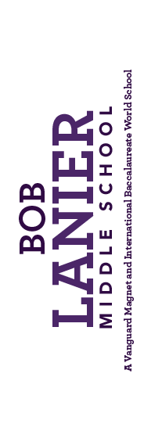
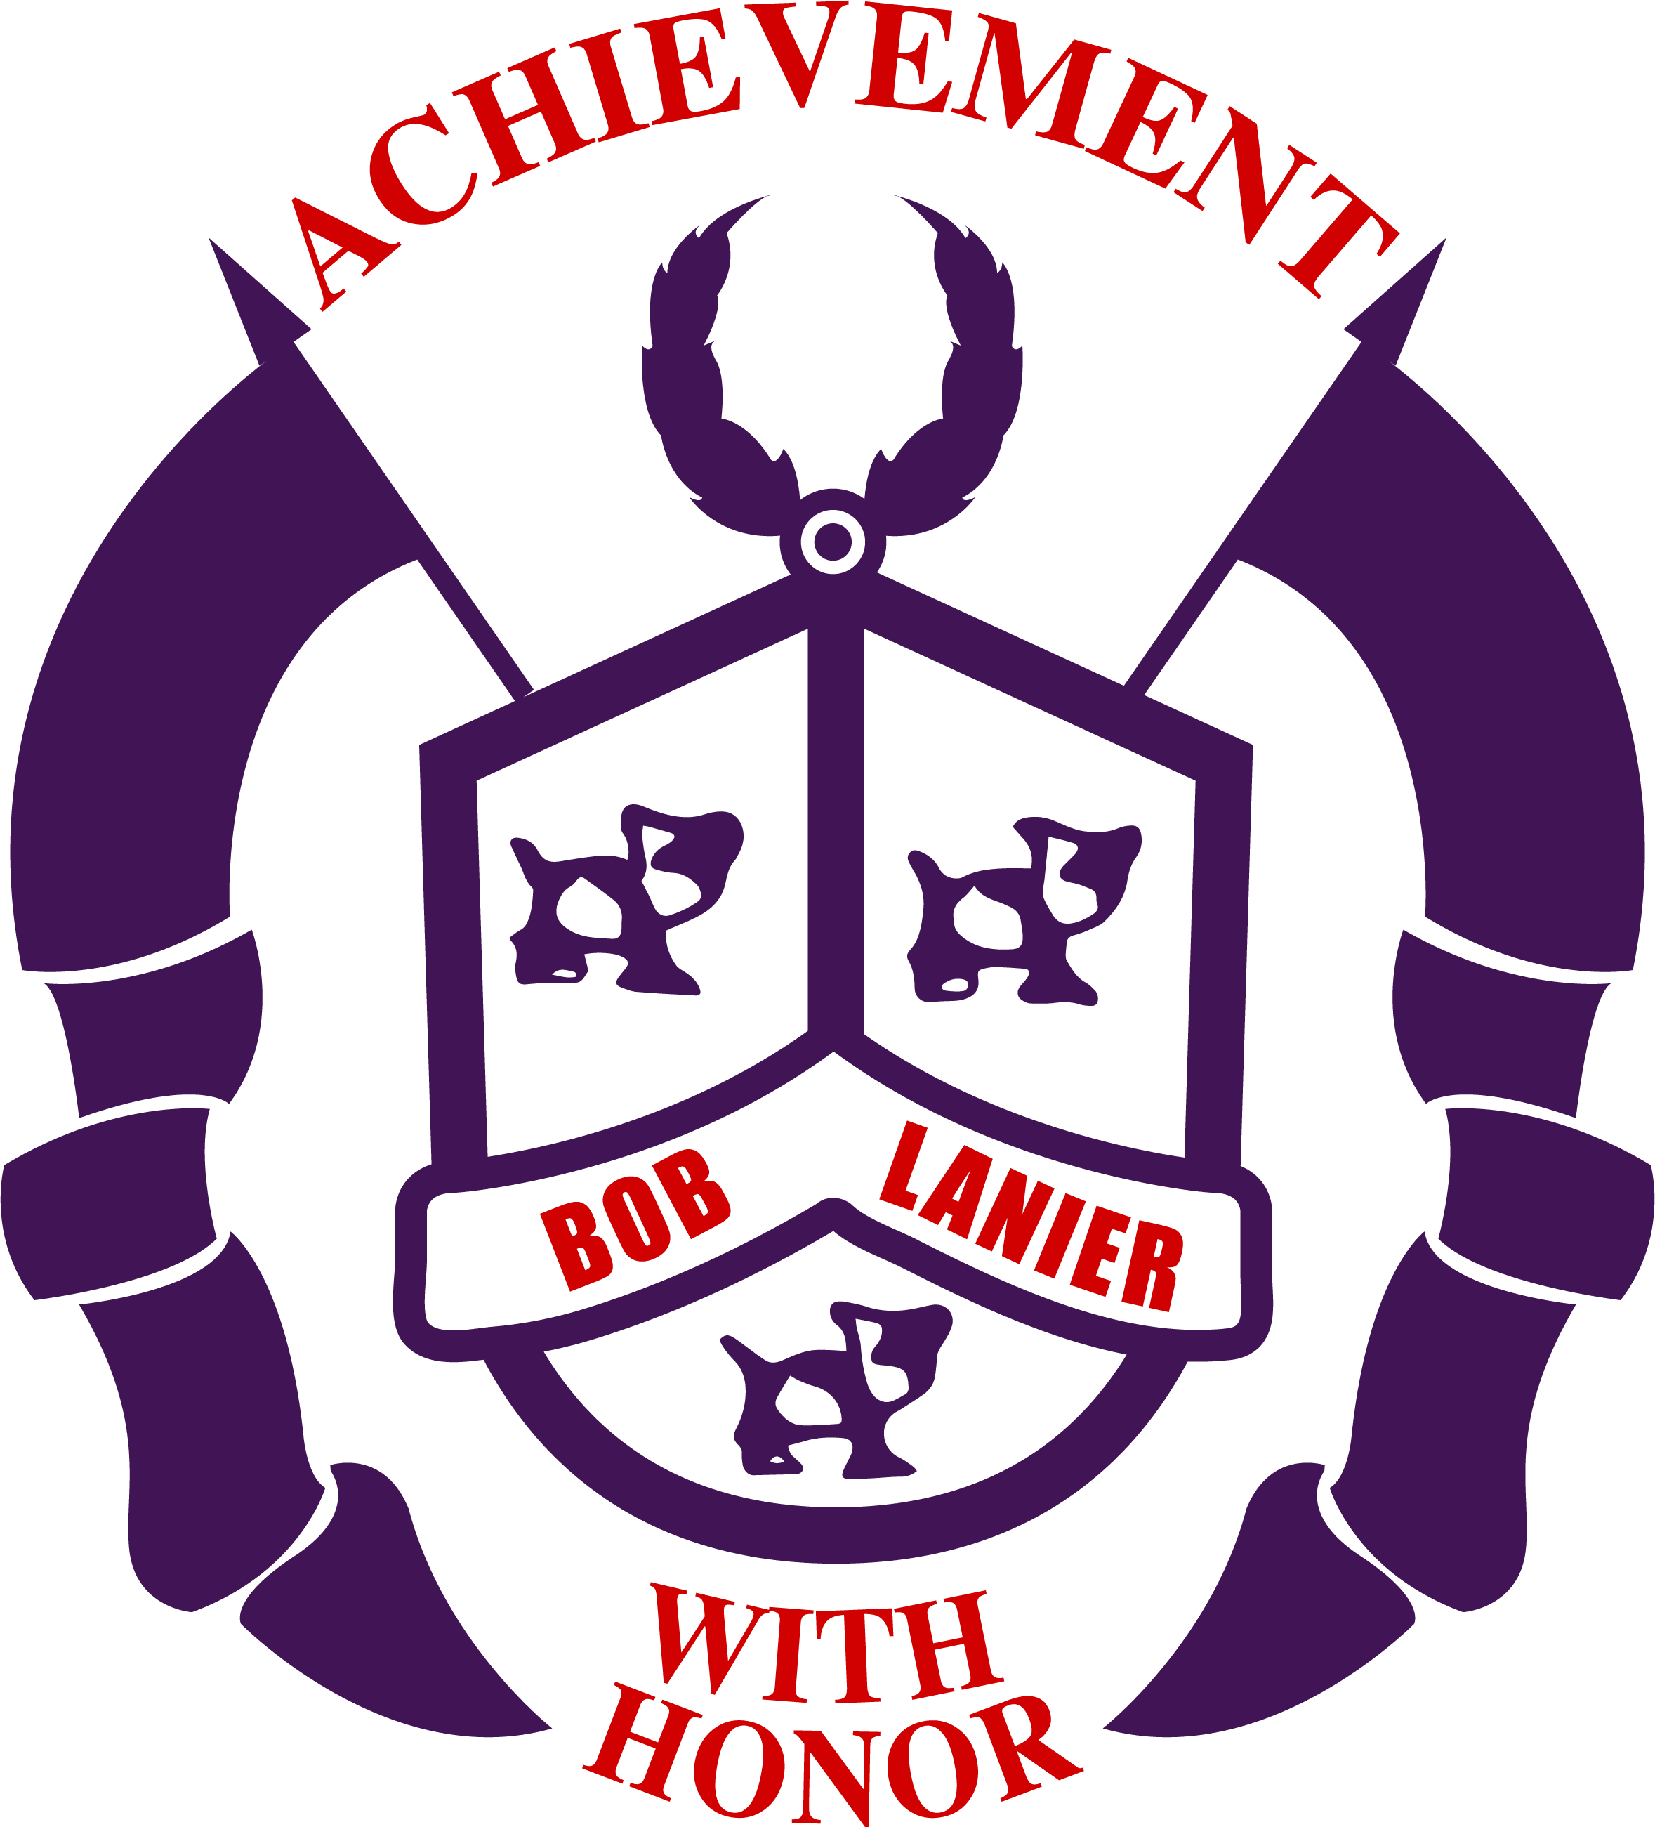
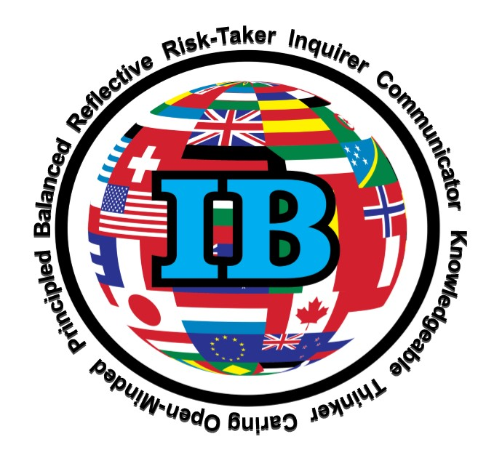
October 23rd, 2020

Dear Lanier Parents/Guardians,
As members of our Lanier community, we take pride in our many wonderful accomplishments, one such being our International Baccalaureate Middle Years Programme (IBMYP) status. Our teachers are passionate about creating globally-minded thinkers who have a love for learning and who understand the importance of giving back to one’s community.
Part of our IBMYP curriculum responsibilities are to guide our students on how to play a part in the ongoing construction of the world community. As an IBMYP campus that ends in year 3 (8th grade), we are required to perform a cross-curricular 8th grade IBMYP Community Project that will allow students to consider how their knowledge and their actions can affect change within a community.
In order to support our students’ efforts, we want to make sure our parents/guardians are aware of this requirement and the student responsibilities in order to complete the project. Please read the Acknowledgement of Responsibilities attached below. Review this document with your child If you have any questions, please do not hesitate to e-mail, Kathleen.rhymes@houstonisd.org.

Thank you,

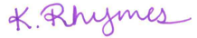
Katie Keenan Rhymes
IB MYP Coordinator
Lanier Middle School

Students will receive a link to a Google form from their PUPS teacher to complete this acknowledgement.

8th Grade IBMYP Community Project
Acknowledgement of Responsibilities
The IB Community Project is a major activity for students to complete in the final year (Year 3 = Grade 8) of the MYP program at Lanier Middle School. Lanier is an authorized IB school with a 3 year MYP programme. In schools in which the MYP finishes with year 3 or 4 of the programme, all students in the final year must complete the community project.
The community project focuses on community and service, encouraging students to explore their right and responsibility to implement service as action in the community. The community project gives students an opportunity to develop awareness of needs in various communities and address those needs through service learning. The community project can be completed individually or collaboratively in groups of a maximum of three students. The choice of the goal or topic for the project is made in consultation with their study lab teacher who has the responsibility for supervising the development of the project according to the MYP Community Project Assessment Criteria and International Baccalaureate Organization guidelines.
The aims of the MYP projects are to encourage and enable students to:
- participate in a sustained, self-directed inquiry within a global context
- generate creative new insights and develop deeper understandings through in-depth investigation
- demonstrate the skills, attitudes and knowledge required to complete a project over an extended period of time
- communicate effectively in a variety of situations
- demonstrate responsible action through, or as a result of, learning
- appreciate the process of learning and take pride in their accomplishments.

Students will be assessed in the four areas below.

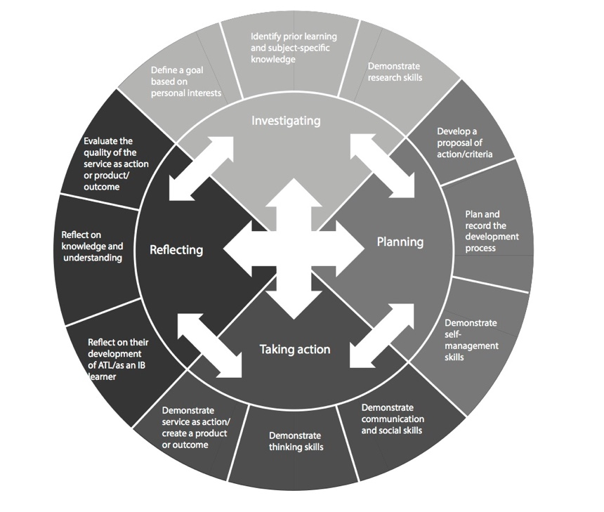
While this project may seem like quite a bit of work, we are confident the rewards will be even greater, both for you as a student and the community whose need you chose to address.

The start date for the project is October 23rd; final presentations will be held March 8th, 2021.

PLEASE VISIT OUR WEBSITE FOR MORE INFORMATION!

